2018 Downtown Container Sponsor

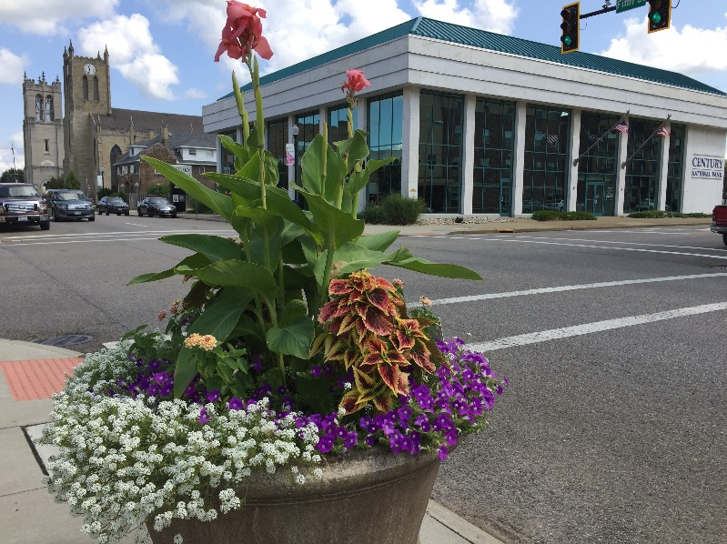
90.00

Garden Society Supporters
We will be celebrating 15 years as a gardening organization that not only educates but enriches the community with color and beauty. We began with just 40 containers scattered around the community that went virtually without flowers. Today, with the help of many businesses and members and individuals who love to see a beautiful city and community, we will be planting 159 containers as well as the Y-Bridge. We have received much recognition for our efforts this past year and it would not have been possible without your generous support. We once again are offering an early opportunity to secure a planter for a discount by signing up by February 15th. We will engrave a plaque for you and place it in one of our many locations. After our containers are planted you will receive a letter thanking you for your support and a map with the location of your plaque. Our members visit the planters on a weekly basis to prune and fertilize and they do quite well into October. Only part of our planters are irrigated and we must hire an individual to help us water. This is a major part of our budget. You can be a part of the 2018 summer beautification of downtown by downloading the form and sending in your sponsorship. We accept donations as well for the Y-Bridge. Just indicate on the form your amount.
Our 15th year “Spring Garden Symposium” is March 3, 2018. Save the date!

Muskingum Valley Garden Society- Downtown Container Sponsor 2018

ORDER FORM for Downtown Containers (Order by Feb 15th for discount)

Name ____________________________________
Phone _____________
E-Mail __________________________
Address____________________________________
_____________________________________
Option A.
Cost 90.00 per container (name as it would appear on plaque)

Sponsored by

___________________________________________

___________________________________________

Number _______ Total Amt.____________

Option B. Order a container with the following format;

Cost 90.00 each
In Memory of

(name) __________________________ Total_________

Happy Birthday

(name) _________________________ Total_________

Happy Anniversary

(name) ________________________ Total _________

Make checks payable to: Muskingum Valley Garden Society
MAIL TO : Muskingum Valley Garden Society
P.O. Box 2688
Zanesville, Oh 43702

I would like to make a donation for the y-Bridge basket _____________AMT.

